**STREETS To fix**

{'Geary Street,Jones Street,Geary Street',

'Jones Street,Sutter Street,Jones Street',

'Kearny Street,Kearny Street,Columbus Avenue',

'Kearny Street,Kearny Street,Post Street',

'Kearny Street,Kearny Street,Sutter Street',

'Larkin Street,Larkin Street,Golden Gate Avenue',

"Larkin Street,O'Farrell Street,Larkin Street",

'Larkin Street,Sutter Street,Larkin Street',

'Mason Street,Sutter Street,Mason Street',

'Mission Street,11th Street,Mission Street',

'Montgomery Street,Jackson Street,Montgomery Street',

'Montgomery Street,Montgomery Street,Jackson Street',

'Montgomery Street,Washington Street,Montgomery Street',

'Post Street,Kearny Street,Post Street',

'Stockton Street,Stockton Street,Jackson Street',

'Stockton Street,Stockton Tunnel,Stockton Street',

'Sutter Street,Powell Street,Sutter Street',

'Van Ness Avenue,Golden Gate Avenue,Van Ness Avenue',

'Van Ness Avenue,Hayes Street,Van Ness Avenue',

'Van Ness Avenue,McAllister Street,Van Ness Avenue',

'Van Ness Avenue,Van Ness Avenue,Bush Street',

'Van Ness Avenue,Van Ness Avenue,Eddy Street',

'Van Ness Avenue,Van Ness Avenue,Fell Street',

'Van Ness Avenue,Van Ness Avenue,Golden Gate Avenue',

'Van Ness Avenue,Van Ness Avenue,Grove Street',

'Van Ness Avenue,Van Ness Avenue,Turk Street'}

{'Geary Street,Jones Street,**Geary Street**',

'Geary Street,Larkin Street,Polk Street',

'Geary Street,Leavenworth Street,Hyde Street'}

Since the direction is East to West LARKIN -> POLK

JONES STREET -- > **LEAVENWORTH STREET**

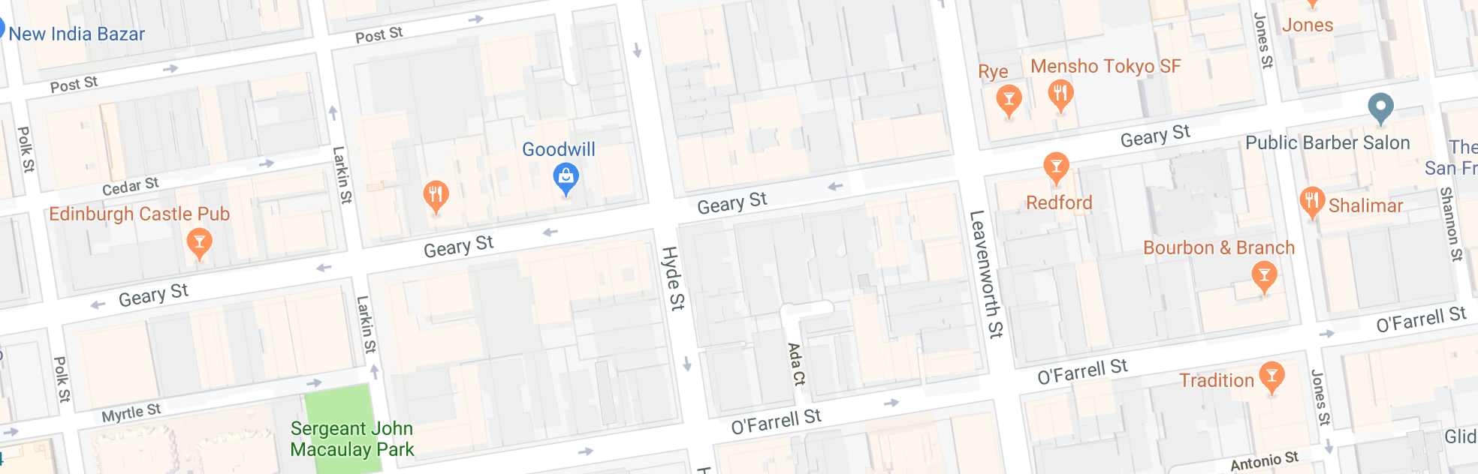

{'Jones Street,Antonio Street,Ellis Street',

'Jones Street,Bush Street,Sutter Street',

'Jones Street,Colin Place,Geary Street',

'Jones Street,Ellis Street,Eddy Street',

'Jones Street,Post Street,Colin Place',

'Jones Street,Sutter Street,**Jones Street**'}

Since SUTTER TO BUSH exists,

The remaining one should be SUTTER TO POST

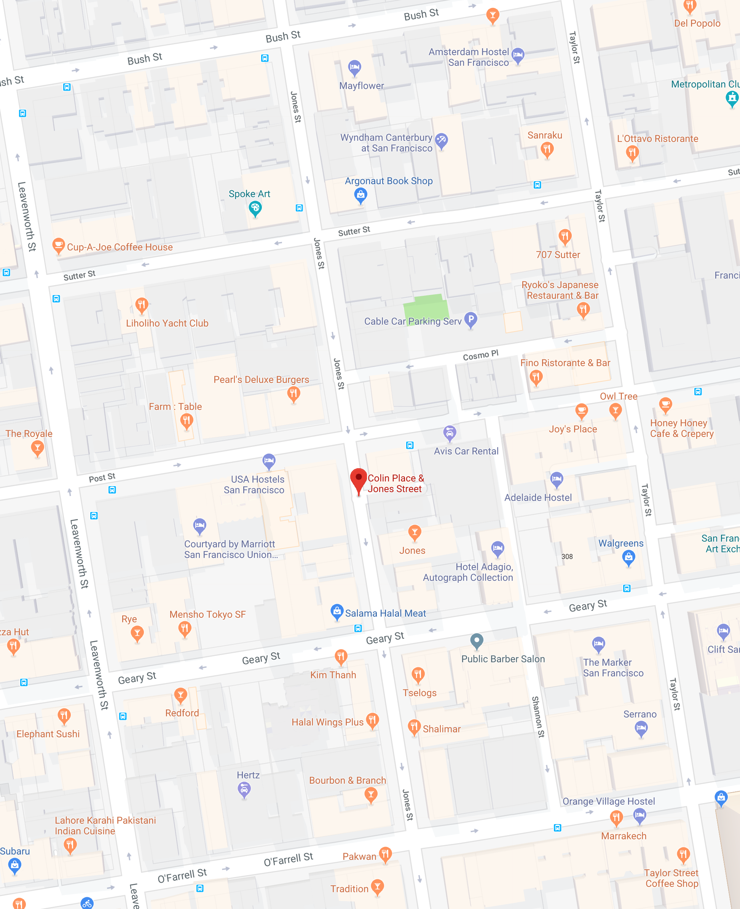

{'Kearny Street,Geary Street,Maiden Lane',

'Kearny Street,Hardie Place,Bush Street',

'Kearny Street,Kearny Street,Columbus Avenue',

'Kearny Street,**Kearny Street**,Post Street',

'Kearny Street,**Kearny Street**,Sutter Street',

'Kearny Street,Nottingham Place,Broadway'}

Since GEARY to MAIDEN,

Should be MAIDEN to POST

And POST TO SUTTER STREET

JACKSON to Columbus

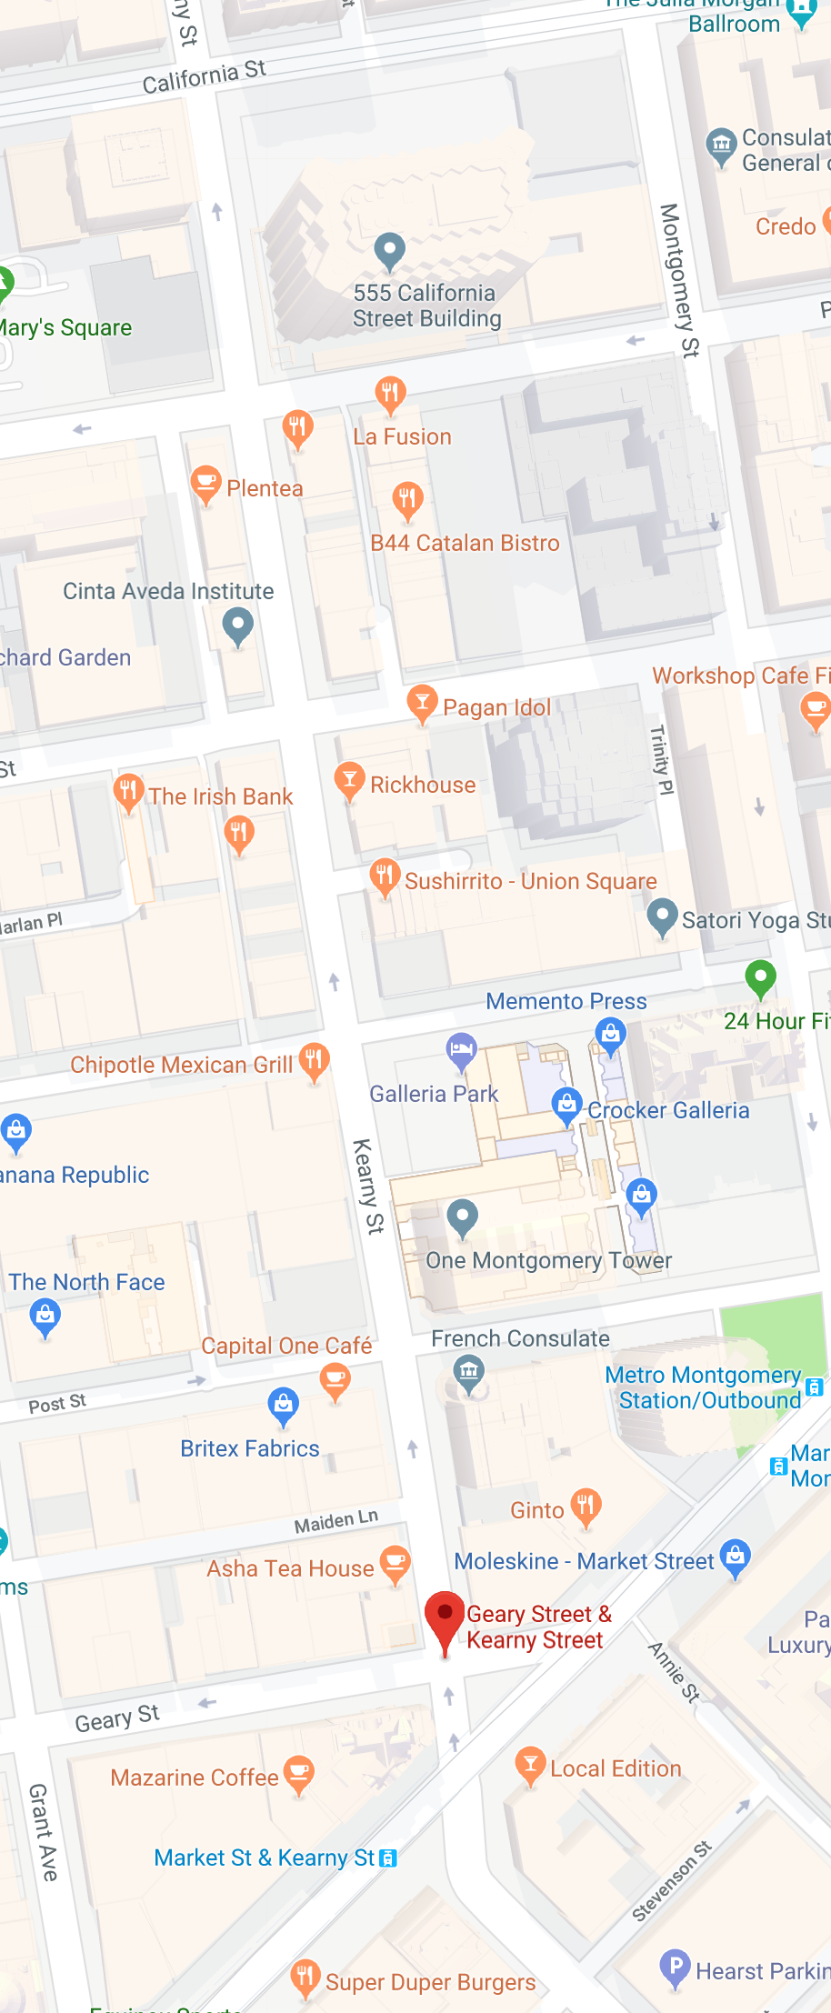

{'Larkin Street,Cedar Street,Post Street',

'Larkin Street,Larkin Street,Golden Gate Avenue',

'Larkin Street,McAllister Street,Fulton Street',

'Larkin Street,Myrtle Street,Geary Street',

"Larkin Street,O'Farrell Street,**Larkin Street**",

'Larkin Street,Sutter Street,**Larkin Street**',

'Larkin Street,Turk Street,Eddy Street'}

Since EDDY to TURK is south to north,

O’Farrell goes to **Myrtle**

Sutter goes to **BUSH**

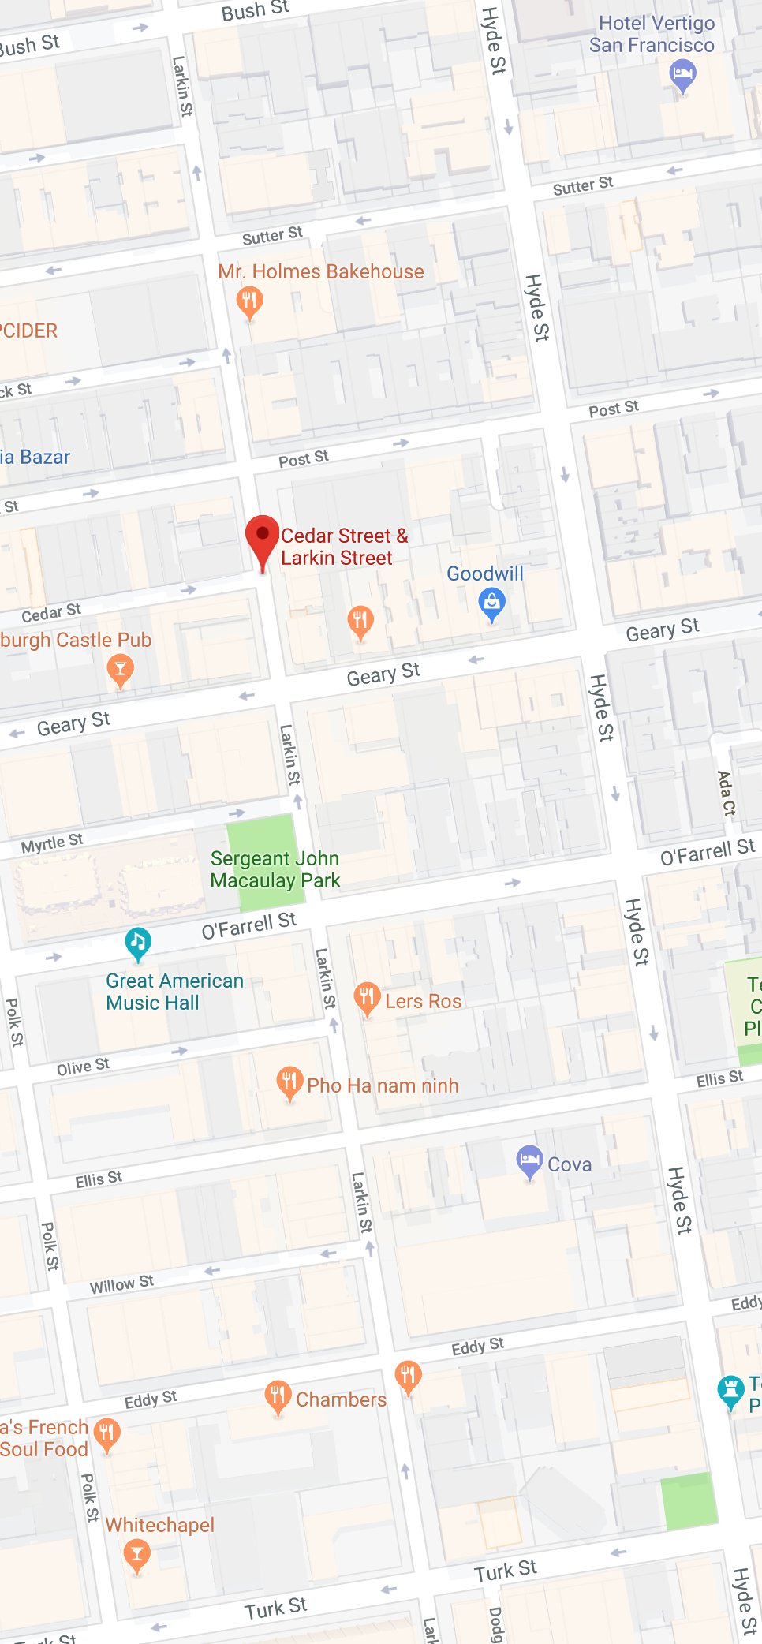

{'Montgomery Street,Bush Street,Sutter Street',

'Montgomery Street,Clay Street,Commercial Street',

'Montgomery Street,Jackson Street,**Montgomery Street**',

'Montgomery Street,Montgomery Street,Jackson Street',

'Montgomery Street,Verdi Place,Broadway',

'Montgomery Street,Verdi Place,Pacific Avenue',

'Montgomery Street,Washington Street,Montgomery Street'}

In [ ]:

BUSH to SUTTER goes south

**Pacific avenue** goes to Jackson

Jackson goes to **Washington St.**

Washington pl. goes to **Clay St.**

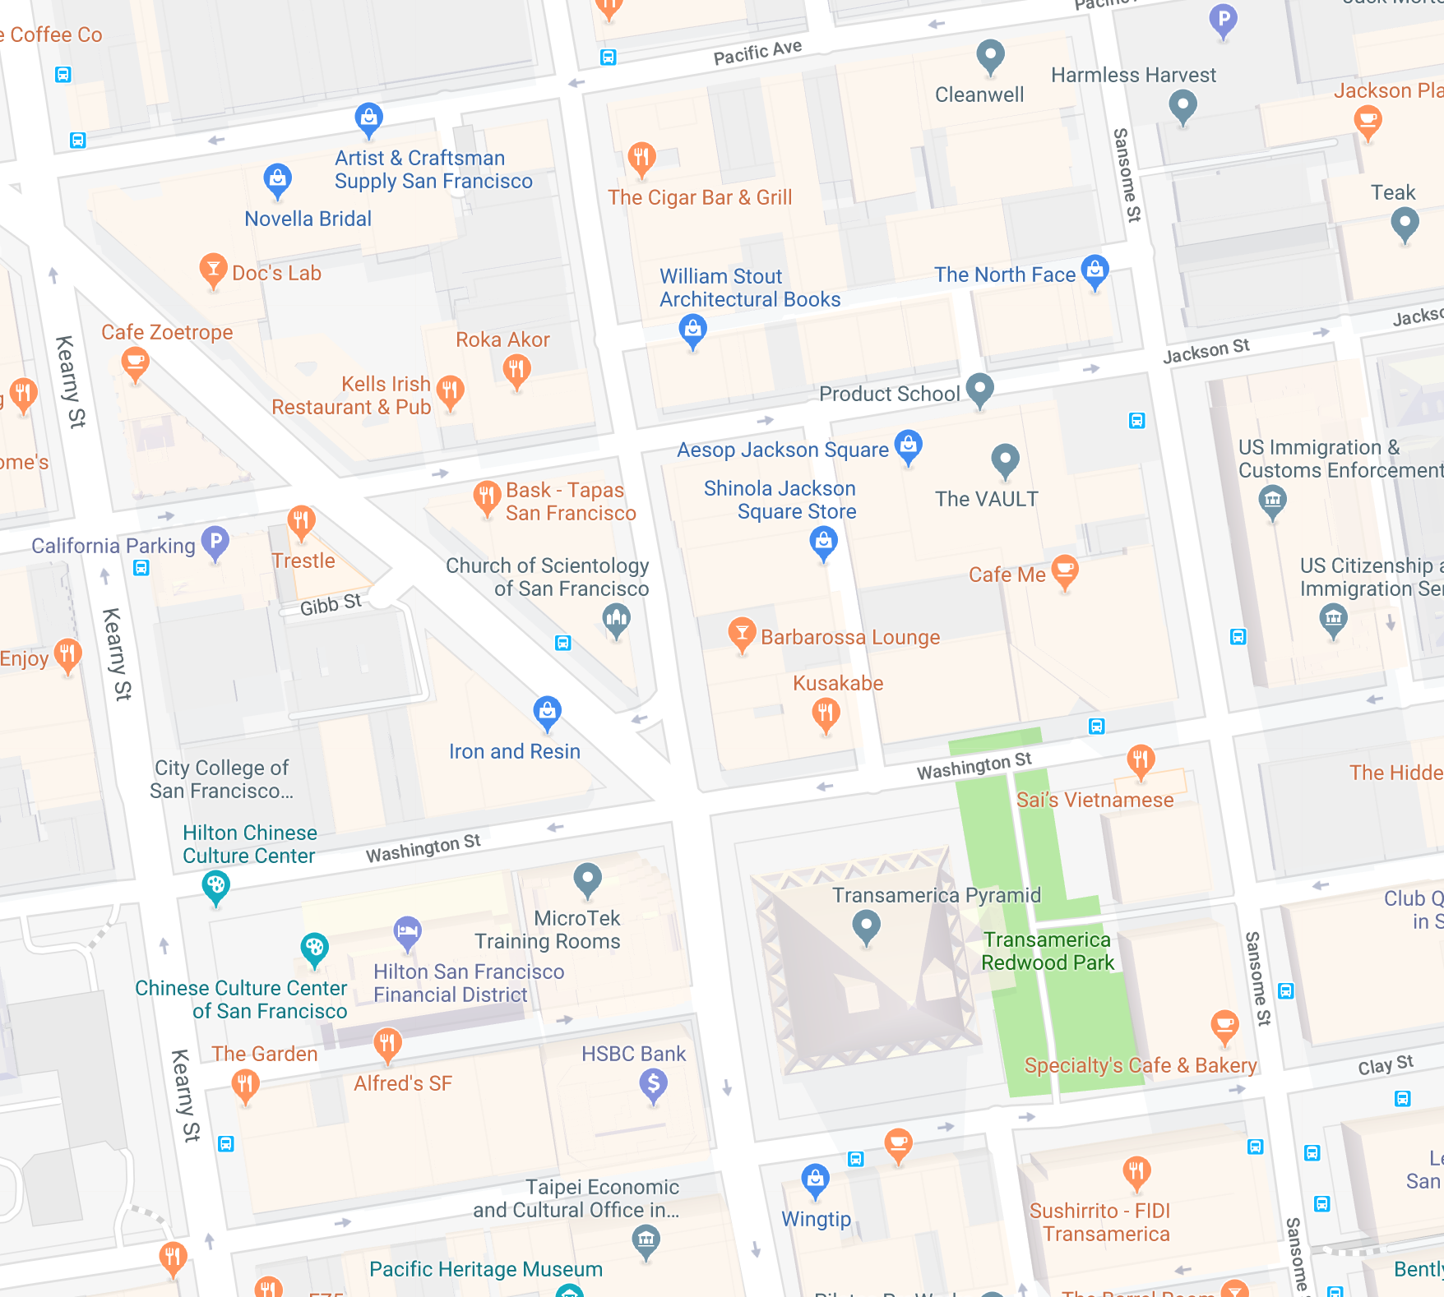

{'Post Street,Kearny Street,Post Street',

'Post Street,Larkin Street,Meacham Place'}

Taking a guess to **MONTGOMERY STREET**

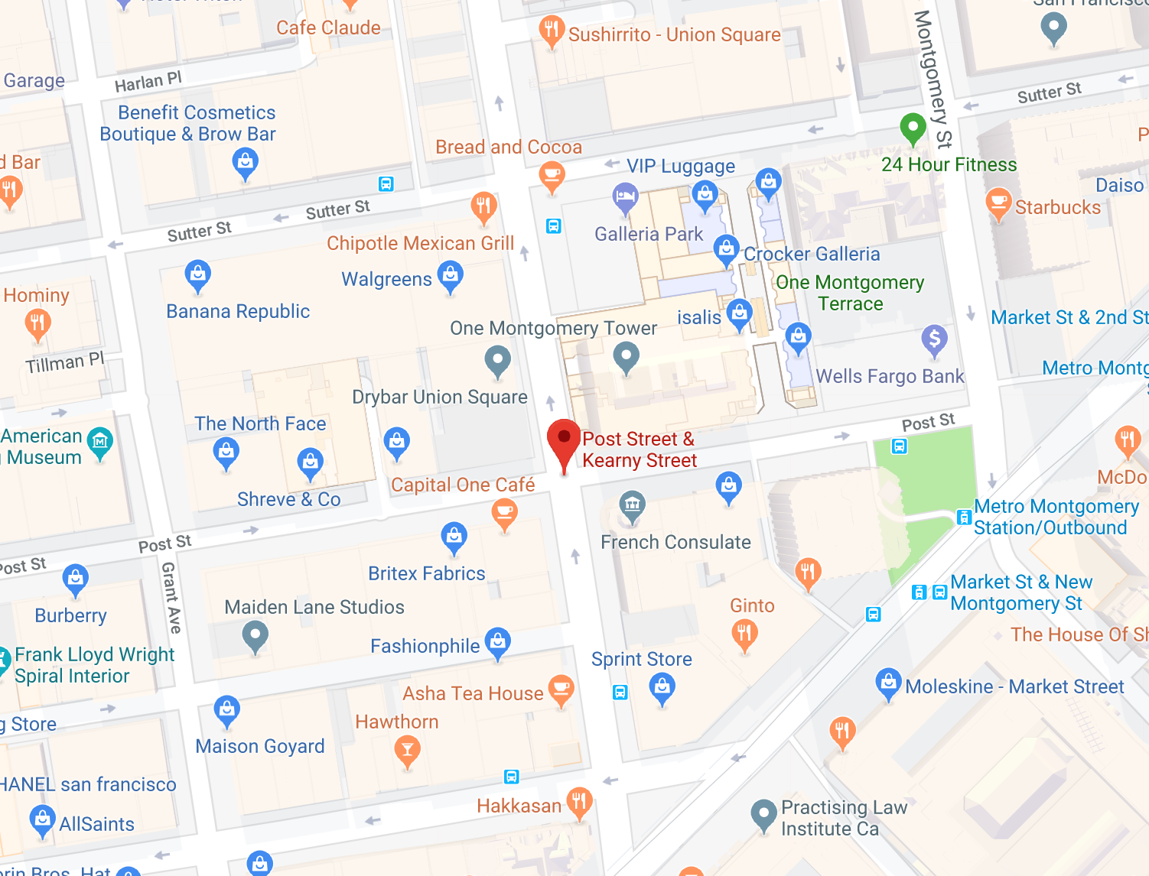

{'Stockton Street,Green Street,Union Street',

'Stockton Street,**Stockton Street**,Jackson Street',

'Stockton Street,Stockton Tunnel,Stockton Street'}

Goes NORTH, assumes WASHINGTON to Jackson Street

Assume Stockton tunnel to CLAY STREET

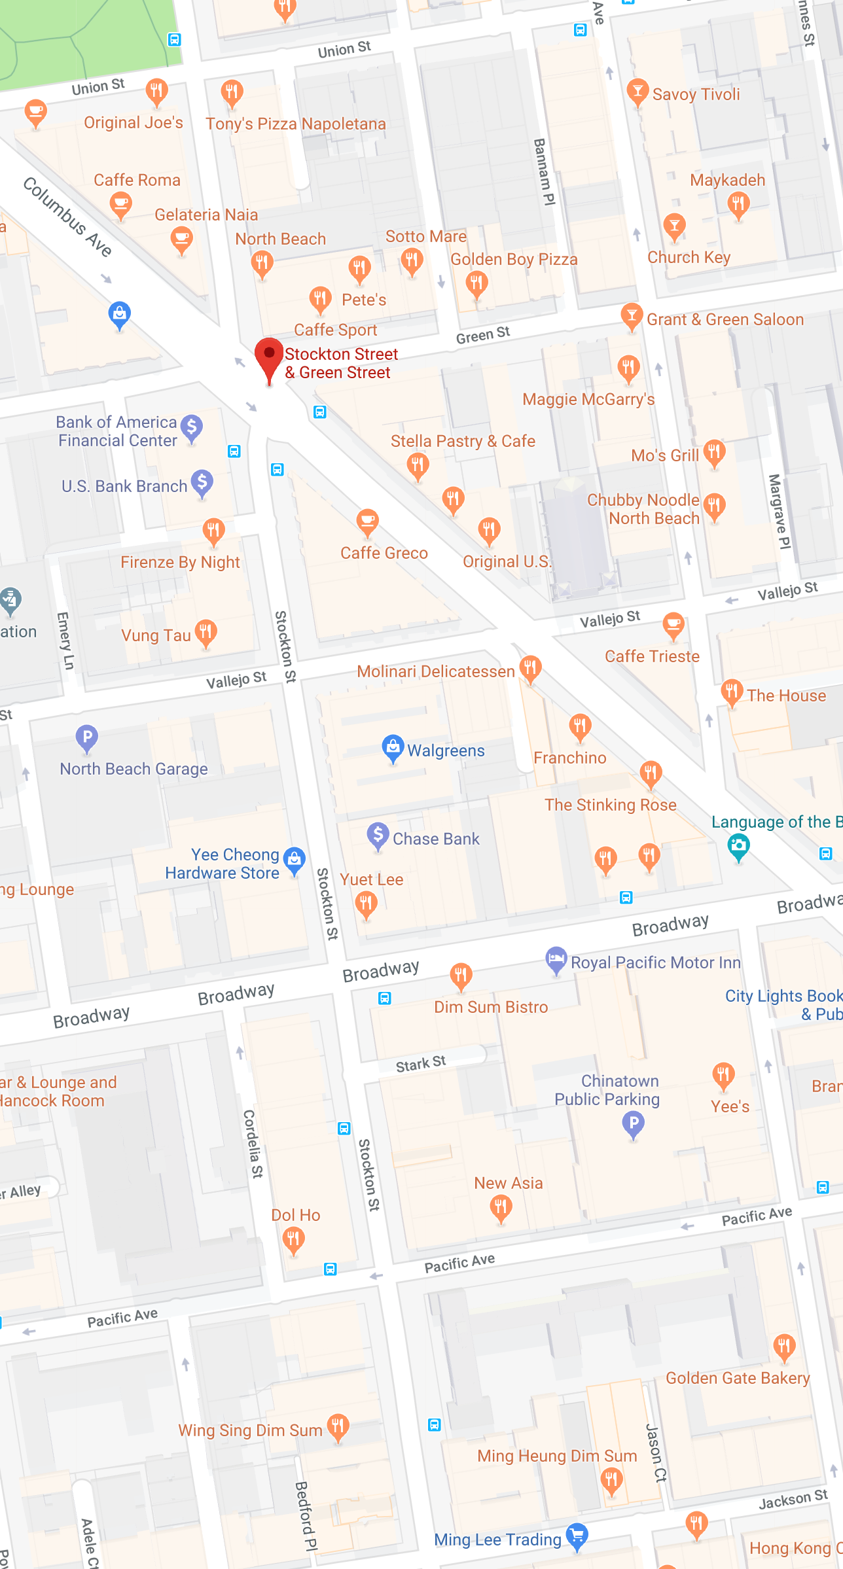

{'Sutter Street,Mason Street,Taylor Street',

'Sutter Street,**Powell Street**,Sutter Street'}

**Assume Powell to MASON street**

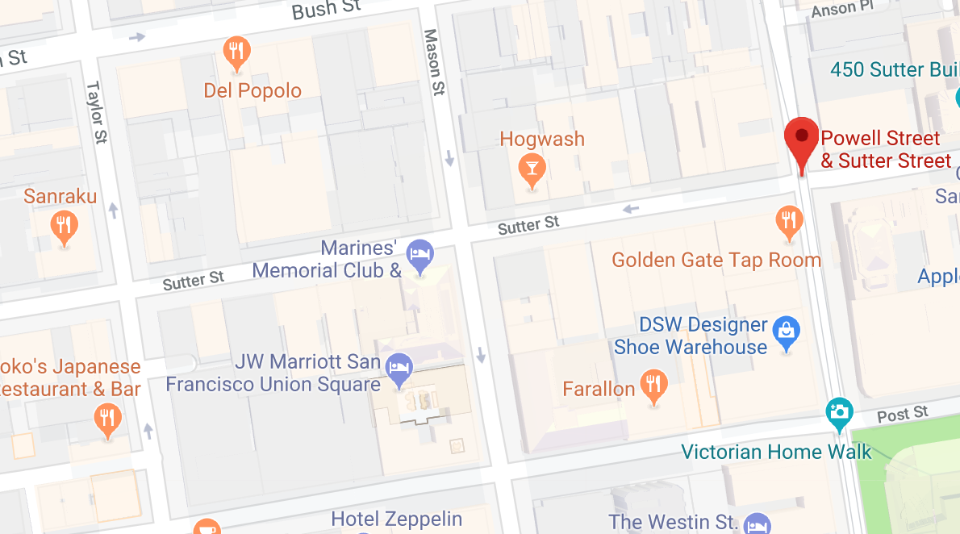

{'Van Ness Avenue,Bush Street,Austin Street',

'Van Ness Avenue,Bush Street,Fern Street',

'Van Ness Avenue,Clay Street,Washington Street',

'Van Ness Avenue,Daniel Burnham Court,Post Street',

'Van Ness Avenue,Geary Boulevard,Myrtle Street',

'Van Ness Avenue,Golden Gate Avenue,**Van Ness Avenue',**

'Van Ness Avenue,Hayes Street,**Van Ness Avenue',**

'Van Ness Avenue,McAllister Street,**Van Ness Avenue',**

"Van Ness Avenue,O'Farrell Street,Alice B. Toklas Place",

'Van Ness Avenue,Pacific Avenue,Broadway',

'Van Ness Avenue,Post Street,Hemlock Street',

'Van Ness Avenue,**Van Ness Avenue,**Bush Street',

'Van Ness Avenue,**Van Ness Avenue**,Eddy Street',

'Van Ness Avenue,**Van Ness Avenue**,Fell Street',

'Van Ness Avenue,**Van Ness Avenue**,Golden Gate Avenue',

'Van Ness Avenue,**Van Ness Avenue**,Grove Street',

'Van Ness Avenue,**Van Ness Avenue**,Turk Street'}

Since Pacific goes North to broad way

Golden Gate goes to **TURK**

{'Mission Street,11th Street,Mission Street',

'Mission Street,25th Street,26th Street',

'Mission Street,6th Street,7th Street',

"Mission Street,Julia Street,Angelo's Alley"}

In [ ]: